**Project Work Progress Report No 2**

Date: 02/23/2019 Team #: 33

Project Title: Anti-theft Package Security Home System (APSHS)

Submitted by Gregory Escobar, Stephen Benavides, Shawn Carnevale, Geomar Reyes

1. Project progress since last report:

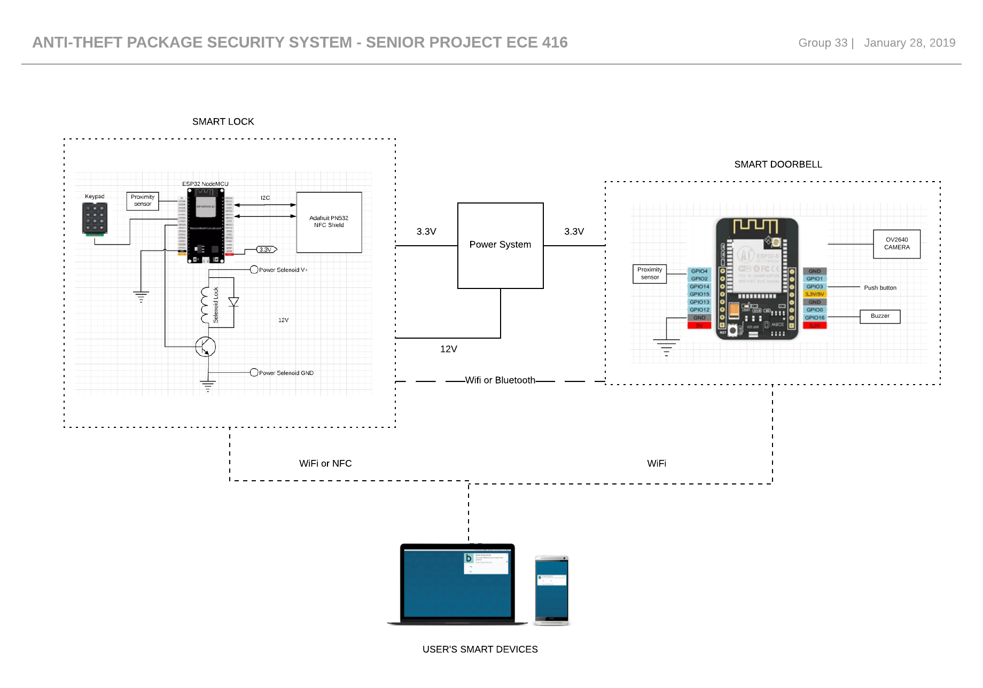This is an updated version of the schematic for the whole project

Figure 1 Anti-theft package Security System

**Communication between ESP32S and Adafruit PN532**

Our team is still working to stablish communication between the ESP32-WROOM-32 and the PN532 using I2C communication protocol.

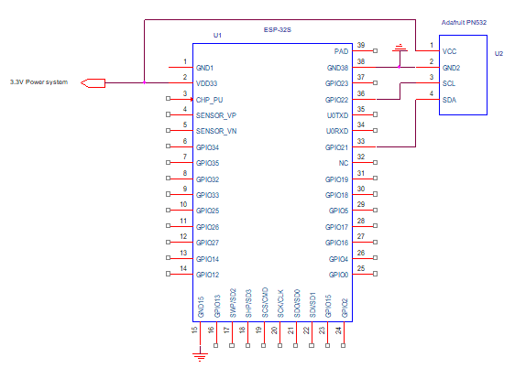

Figure 2 ESP32S and PN532 i2C wiring guide

**Power System**

For the power system our team have just picked out and received some new equipment. The focus this week was to find a way to charge and discharge the battery to and to keep a steady voltage because most of our components operate between 3.3-5 volts. The main issue was to design something that was simple and to keep it as affordable as possible. We found the solution of how to do that with a single component which was affordable and met our needs and specifications. Next week the goal will be to do more schematic work to finalize the design so we can move forward to start to build our power system onto a breadboard.

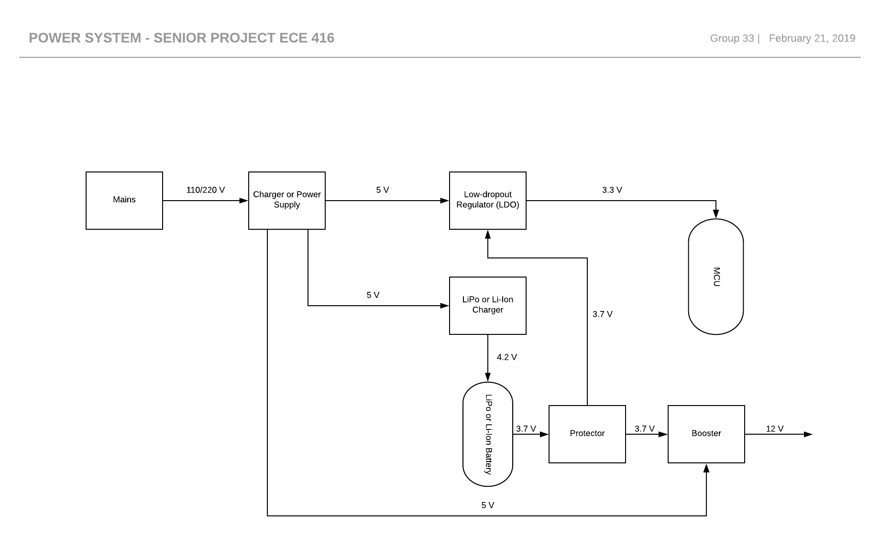

Figure 3 Power System

1. Milestones achieved:

Power System design was finalized by Shawn Carnevale and Gregory Escobar 02/21/19

1. Problems and roadblocks, if any:
2. Is project on schedule? YES__X___ NO____
3. Next steps: (elaborate specifically on any problems listed in 3 and if the answer in 4. Is NO) (You may use more pages, if needed)